Mongo DB
- Mongo db takes a document oriented design
- JSON like structure
- Value and key pair of different types
- It offers greater reliability , security and efficiency in addition to flexibility
- It maintains several copies of data using replication or replica sets and deploy them on various servers
- You can index fields in mongo db as either primary or secondary , this improves search performance in the database
- Adhoc queries are temporary commands that provide different returns for executing queries
- Mongo db is capable of scaling horizontally with the help of sharding Distributing large data sets across different data collections , with the help of shard key
- Load balancing helps to reduce the load on each server
- File Storage you can use MongoDB as a file system known as GridFS that comes with data replication and load balancing features for multiple computers
- Aggregation : Data aggregation allows users to get similar results to those obtained for the SQL clause GROUP BY
  - Aggregation pipeline
  - Single purpose aggregation
  - Map reduce function
- Capped collection : that handles data insertion order

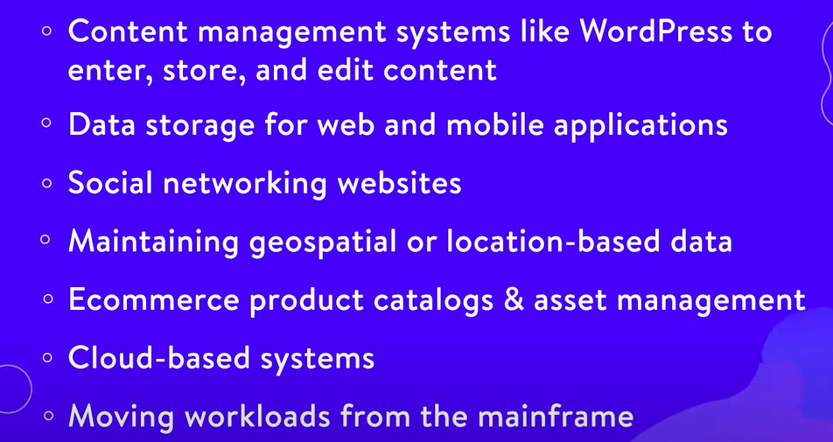

SQL : Facilitates database integrity testing

Relational
- Structured
- Relation between the tables
- Data consistency
- Security – encrypt certain tables
- Easy backup and recovery
Non Relational
- Key value pair
- Column store – optimized for performance
- Graph database
- Document store databases – Mongo DB
- Flexibility
- High scalability
- Cost effective

CAP Theorem

Consistency –
Consistency means that the nodes will have the same copies of a replicated data item visible for various transactions.

Availability –
Availability means that each read or write request for a data item will either be processed successfully or will receive a message that the operation cannot be completed.

Partition Tolerance –
Partition tolerance means that the system can continue operating even if the network connecting the nodes has a fault that results in two or more partitions, where the nodes in each partition can only communicate among each other. That means, the system continues to function and upholds its consistency guarantees in spite of network partitions.
